**Personal Portfolio – Sprint 2**

Group number: 39

Jordan Dickson – N9713140

Github Repository: https://github.com/J0RDIE52/IFB299_Personal_Portfolio.git

**Artefact 1** – Writing of Tests

Description: A collection of written tests which are descriptive enough to provide clear insight into how to run specific task oriented tests.

Contribution: The tests were written to provide testing for a broad coverage of functionality to ensure that the webpage performs as expected. Once implemented, the testing will allow the development team to have more efficient debugging capability and the potential for errors will be reduced. The result is a more rigid and secure product which has these testing procedures to save the client time and money.

Evidence:

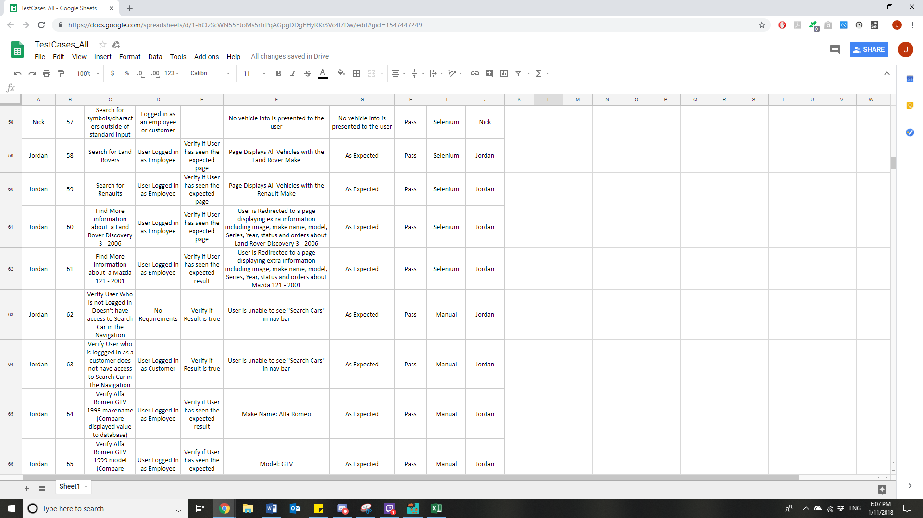

*Figure 1: Screen shot of a collection of written tests*

Full Documentation of Tests Implemented can be found in Repository. Those completed by me are under the Creator Column and are labelled “Jordan”.

**Artefact 2** – SCRUM Management – Iteration/Sprint Plan Update for Sprint 2

(Description about what the artefact is in general)

Description: The Sprint 2 plan which was developed taking upon consideration of feedback from the client to take forward into sprint 2.

Contribution: After completing Sprint 1, there were a few incomplete tasks. Therefore, to ensure the team had clear goals and a measurable amount of tasks that needed to be completed in preparation for release 1, I adopted client feedback to create a new Sprint plan which adhered to knew requested features and removal of less valuable ones. This document is what guided the team to delegate their workloads and ensure there was time to complete all tasks.

Evidence:

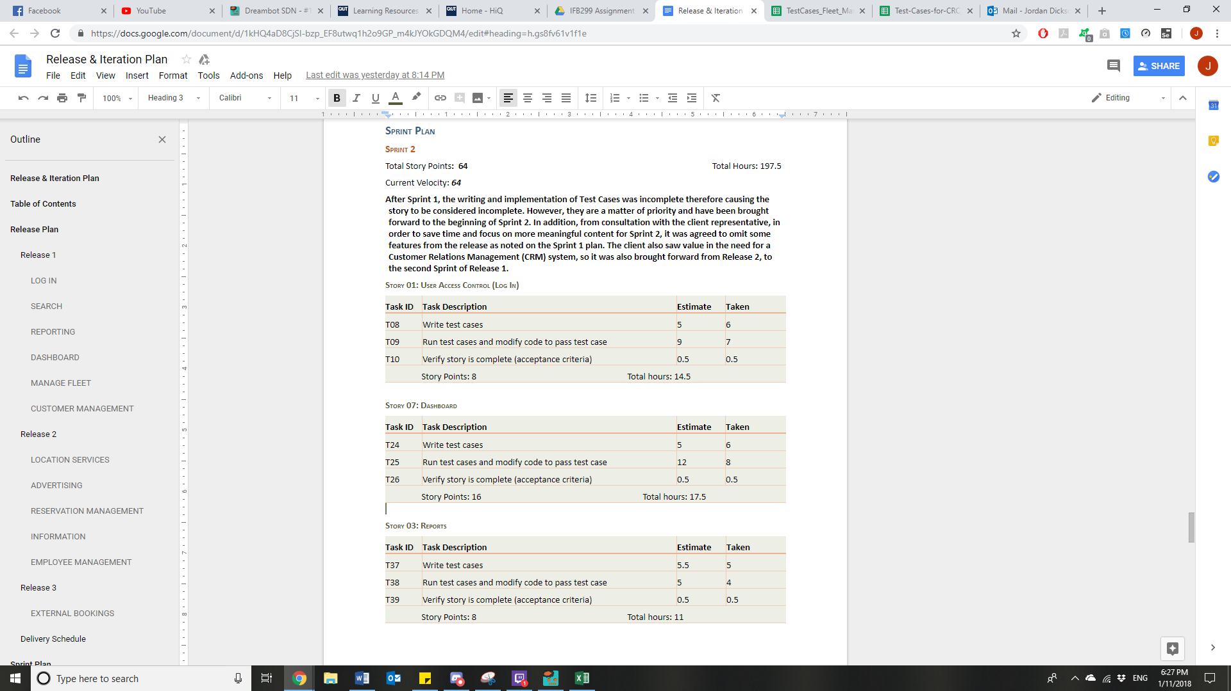

*Figure 2: Screen shot of Sprint 2 Plan*

Full Sprint Plan for the release can be found in Repository. I completed full documentation for Sprint 2 Plan.

**Artefact 3** – Implementation of Tests

Description: The implementation of Written Tests using Selenium and Manual observation

Contribution: The provided written tests were then adopted to be physically tested. Using the Google Chrome Extension, Selenium, an array of tests were employed to ensure that the physical testing demonstrated the results of testing parameters identified by the written tests. Particularly, my focus was on Searching for Cars and Suggested Cars.

Note * To run the tests, ensure that Google Chrome Extension: Selenium IDE 3.4.4 is added to chrome and that the project files (.side files) are opened in the IDE.

Evidence:

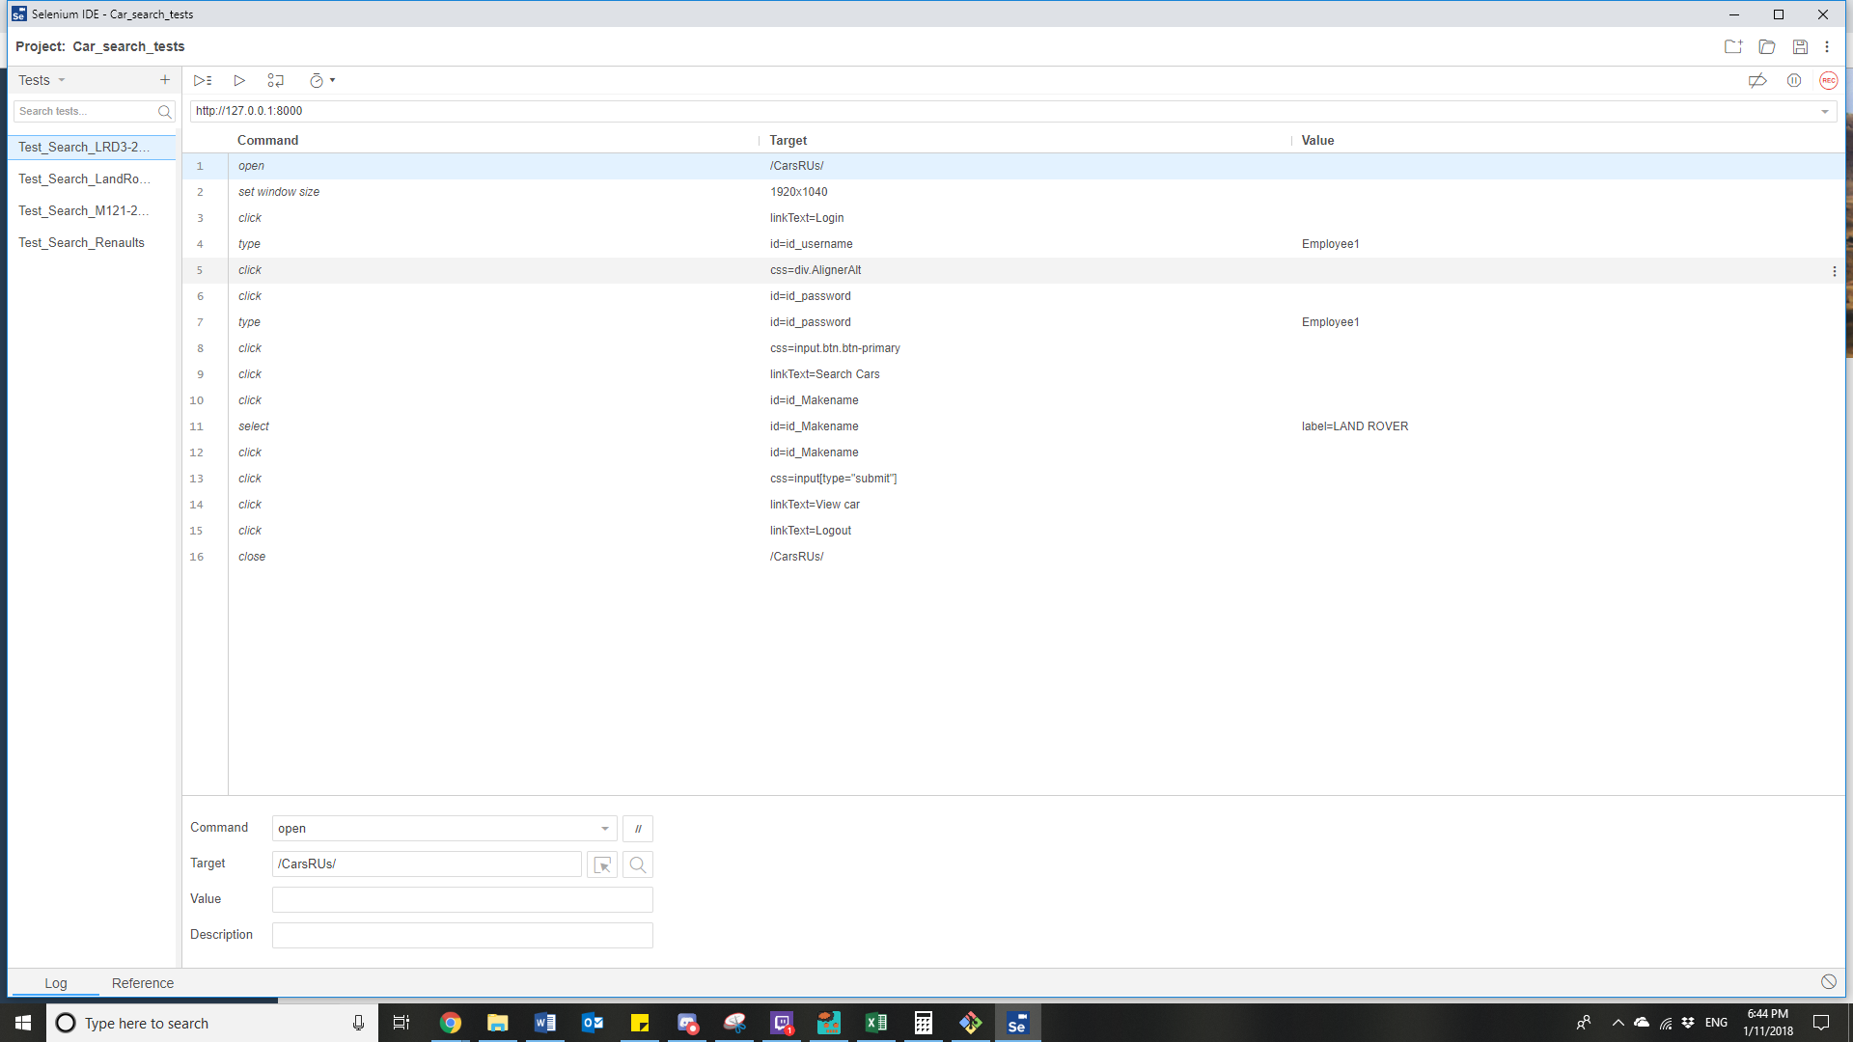

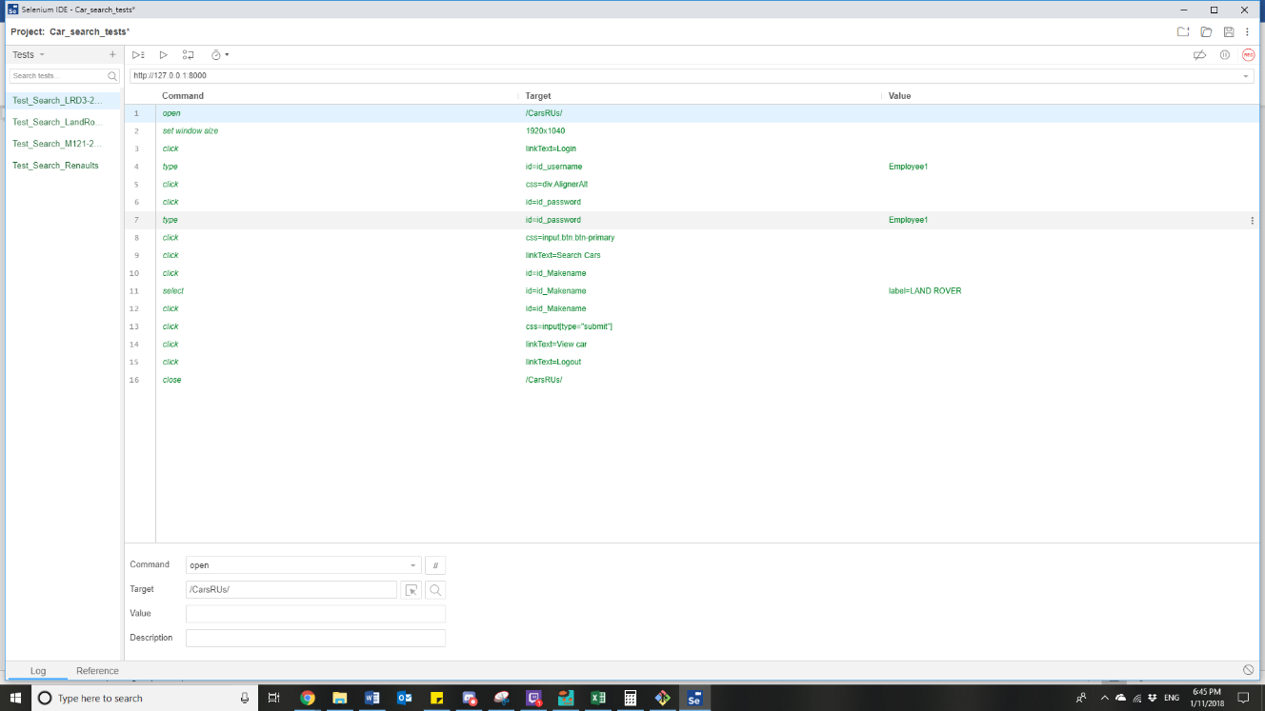*Figure 3: Screenshot of Search Tests in Selenium IDE*

*Figure 4: Screenshot of Search Tests Passing (Indicated by Green Text)*

**Artefact 4** – SCRUM Management – Upkeep of Sprint Burndown Chart

Description: A chart to keep track of daily progress made during the First and Second Sprints.

Contribution: The Burndown chart is very key to efficiently Task Orienting and managing time for developers. It provides a breakdown of the progression in terms of task completion which firstly allows the development team to ensure they are on the track to completing all tasks required in the sprint. In addition, a good burndown chart that remains close to the linear trend is used provide daily and weekly assurances to the client that their financial investments are providing results in terms of project progression. Reflecting on sprint 1, the burndown chart shows deviation from the trend as time progresses. This resulted in an incomplete sprint. Observing this document and keeping clear track of the burndown chart allowed the team to be better focused on completing tasks to keep on track to complete the sprint, which in this case, was successfully completed.

Evidence:

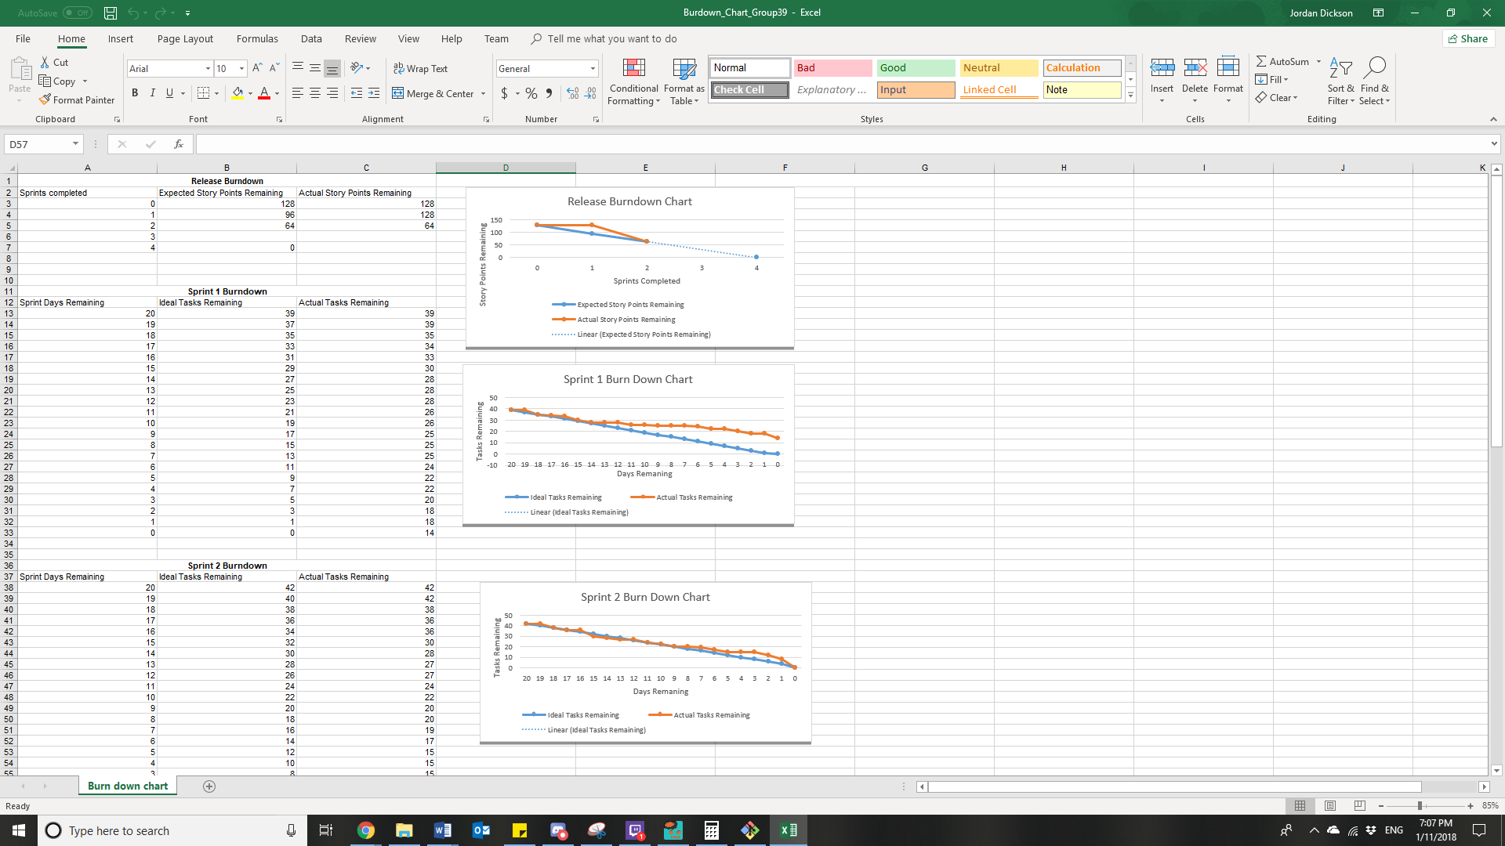

*Figure 5: Screenshot of Burndown Charts*